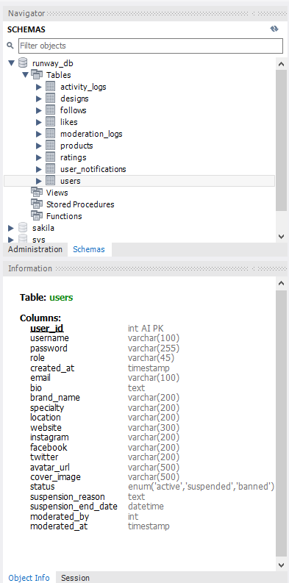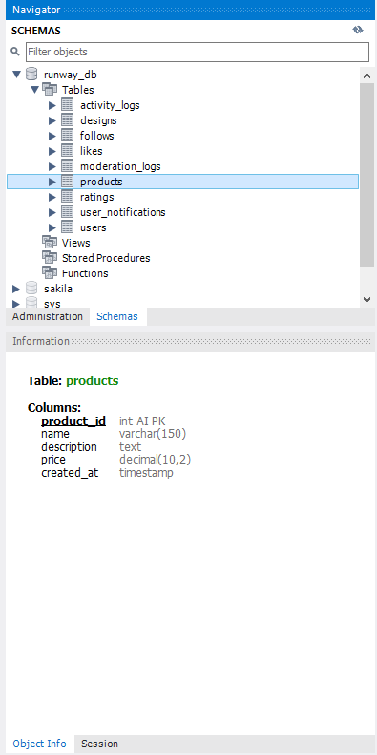

USE runway_db;

SET FOREIGN_KEY_CHECKS = 0;

DROP TABLE IF EXISTS activity_logs;
DROP TABLE IF EXISTS follows;
DROP TABLE IF EXISTS ratings;
DROP TABLE IF EXISTS likes;
DROP TABLE IF EXISTS designs;

SET FOREIGN_KEY_CHECKS = 1;
SET SQL_SAFE_UPDATES = 0;
SET SQL_SAFE_UPDATES = 1;

-- ================= DESIGNS =================
CREATE TABLE designs (
design_id INT AUTO_INCREMENT PRIMARY KEY,
designer_id INT NOT NULL,
title VARCHAR(200) NOT NULL,
description TEXT,
image_url VARCHAR(500) NOT NULL,
season VARCHAR(50),
created_at TIMESTAMP DEFAULT CURRENT_TIMESTAMP,
updated_at TIMESTAMP DEFAULT CURRENT_TIMESTAMP ON UPDATE CURRENT_TIMESTAMP,
FOREIGN KEY (designer_id) REFERENCES users(user_id) ON DELETE CASCADE
);

-- ================= LIKES =================
CREATE TABLE likes (
like_id INT AUTO_INCREMENT PRIMARY KEY,
user_id INT NOT NULL,
design_id INT NOT NULL,
created_at TIMESTAMP DEFAULT CURRENT_TIMESTAMP,
FOREIGN KEY (user_id) REFERENCES users(user_id) ON DELETE CASCADE,
FOREIGN KEY (design_id) REFERENCES designs(design_id) ON DELETE CASCADE,
UNIQUE KEY unique_like (user_id, design_id)
);

-- ================= RATINGS =================
CREATE TABLE ratings (
rating_id INT AUTO_INCREMENT PRIMARY KEY,
user_id INT NOT NULL,
design_id INT NOT NULL,
rating INT NOT NULL,
created_at TIMESTAMP DEFAULT CURRENT_TIMESTAMP,
FOREIGN KEY (user_id) REFERENCES users(user_id) ON DELETE CASCADE,
FOREIGN KEY (design_id) REFERENCES designs(design_id) ON DELETE CASCADE,
UNIQUE KEY unique_rating (user_id, design_id)
);

-- ================= FOLLOWS =================
CREATE TABLE follows (
follow_id INT AUTO_INCREMENT PRIMARY KEY,
follower_id INT NOT NULL,
designer_id INT NOT NULL,
created_at TIMESTAMP DEFAULT CURRENT_TIMESTAMP,
FOREIGN KEY (follower_id) REFERENCES users(user_id) ON DELETE CASCADE,
FOREIGN KEY (designer_id) REFERENCES users(user_id) ON DELETE CASCADE,
UNIQUE KEY unique_follow (follower_id, designer_id)
);

-- ================= ACTIVITY LOGS =================
CREATE TABLE activity_logs (
log_id INT AUTO_INCREMENT PRIMARY KEY,
user_id INT NOT NULL,
action_type VARCHAR(50) NOT NULL,
target_id INT,
details TEXT,
created_at TIMESTAMP DEFAULT CURRENT_TIMESTAMP,
FOREIGN KEY (user_id) REFERENCES users(user_id) ON DELETE CASCADE
);

-- ================= UPDATE USERS TABLE =================
ALTER TABLE users
ADD COLUMN bio TEXT,
ADD COLUMN brand_name VARCHAR(200),
ADD COLUMN specialty VARCHAR(200),
ADD COLUMN location VARCHAR(200),
ADD COLUMN website VARCHAR(300),
ADD COLUMN instagram VARCHAR(200),
ADD COLUMN facebook VARCHAR(200),
ADD COLUMN twitter VARCHAR(200),
ADD COLUMN avatar_url VARCHAR(500),
ADD COLUMN cover_image VARCHAR(500);

INSERT INTO users (username, email, password, role)
VALUES ('admin', 'admin@runway.com', '$2b$10$vI8aWBnW3fID.ZQ4/zo1G.q1lRps.9cGLcZEiGDMVr5yUP1KUOYTa', 'admin');

UPDATE users SET role = 'admin' WHERE email = 'admin@runway.com';

-- Run this in MySQL Workbench to fix admin login
UPDATE users SET password = '$2b$10$vI8aWBnW3fID.ZQ4/zo1G.q1lRps.9cGLcZEiGDMVr5yUP1KUOYTa'
WHERE email = 'admin@runway.com';

-- Or delete and recreate admin with correct password:
DELETE FROM users WHERE email = 'admin@runway.com';
INSERT INTO users (username, email, password, role)
VALUES ('admin', 'admin@runway.com', '$2b$10$vI8aWBnW3fID.ZQ4/zo1G.q1lRps.9cGLcZEiGDMVr5yUP1KUOYTa', 'admin');

SELECT * FROM users WHERE email = 'admin@runway.com';

DELETE FROM users WHERE email = 'admin@runway.com' AND user_id != 2;

UPDATE users
SET password = '$2b$10$vI8aWBnW3fID.ZQ4/zo1G.q1lRps.9cGLcZEiGDMVr5yUP1KUOYTa',
role = 'admin'
WHERE user_id = 2;

SELECT user_id, username, email, role, LENGTH(password) as pass_length
FROM users WHERE email = 'admin@runway.com';

UPDATE users SET role = 'admin' WHERE email = 'admin2@runway.com';

UPDATE users u1
JOIN users u2 ON u2.email = 'admin2@runway.com'
SET u1.password = u2.password
WHERE u1.email = 'admin@runway.com';

-- Add status fields to users table
ALTER TABLE users ADD COLUMN status ENUM('active', 'suspended', 'banned') DEFAULT 'active';
ALTER TABLE users ADD COLUMN suspension_reason TEXT DEFAULT NULL;
ALTER TABLE users ADD COLUMN suspension_end_date DATETIME DEFAULT NULL;
ALTER TABLE users ADD COLUMN moderated_by INT DEFAULT NULL;
ALTER TABLE users ADD COLUMN moderated_at TIMESTAMP DEFAULT NULL;

-- Add moderation fields to designs table
ALTER TABLE designs ADD COLUMN status ENUM('active', 'hidden', 'under_review') DEFAULT 'active';
ALTER TABLE designs ADD COLUMN moderation_reason TEXT DEFAULT NULL;
ALTER TABLE designs ADD COLUMN moderated_by INT DEFAULT NULL;
ALTER TABLE designs ADD COLUMN moderated_at TIMESTAMP DEFAULT NULL;
ALTER TABLE designs ADD COLUMN appeal_message TEXT DEFAULT NULL;

-- Create moderation log table
CREATE TABLE moderation_logs (
log_id INT AUTO_INCREMENT PRIMARY KEY,
admin_id INT NOT NULL,
target_type ENUM('user', 'design') NOT NULL,
target_id INT NOT NULL,
action VARCHAR(50) NOT NULL,
reason TEXT,
created_at TIMESTAMP DEFAULT CURRENT_TIMESTAMP,
FOREIGN KEY (admin_id) REFERENCES users(user_id)
);

-- Create user notifications table
CREATE TABLE user_notifications (
notification_id INT AUTO_INCREMENT PRIMARY KEY,
user_id INT NOT NULL,
type ENUM('suspension', 'design_hidden', 'design_deleted', 'warning') NOT NULL,
message TEXT NOT NULL,
is_read BOOLEAN DEFAULT FALSE,
created_at TIMESTAMP DEFAULT CURRENT_TIMESTAMP,
FOREIGN KEY (user_id) REFERENCES users(user_id)
);

